# AWS Project Implementation – Yatharth Barrendia

## Step 1: Launch EC2 Instances Using a Bash Script

* Go to the [AWS EC2 Console](https://console.aws.amazon.com/ec2)
* Click on **Launch Instance**
* Fill in the details:
* **Name**: server-1, server-2, server-3
* **Amazon Machine Image (AMI)**: Select **Ubuntu Server 24.04 LTS (HVM), SSD Volume Type**
* **Instance type**: t3.micro (Free Tier eligible)
* **Key pair**: Create new key-pair name (yatharth)
* **Network Settings**: Created VPC (project-vpc)
* **Security Group:** server-1
* **Type**: HTTP | **Protocol**: TCP | **Port**: 80 | **Source**: Anywhere (0.0.0.0/0)
* **Type**: SSH | **Protocol**: TCP | **Port**: 22 | **Source**: My IP
* **User Data contains:** "Welcome to Yatharth Server!"

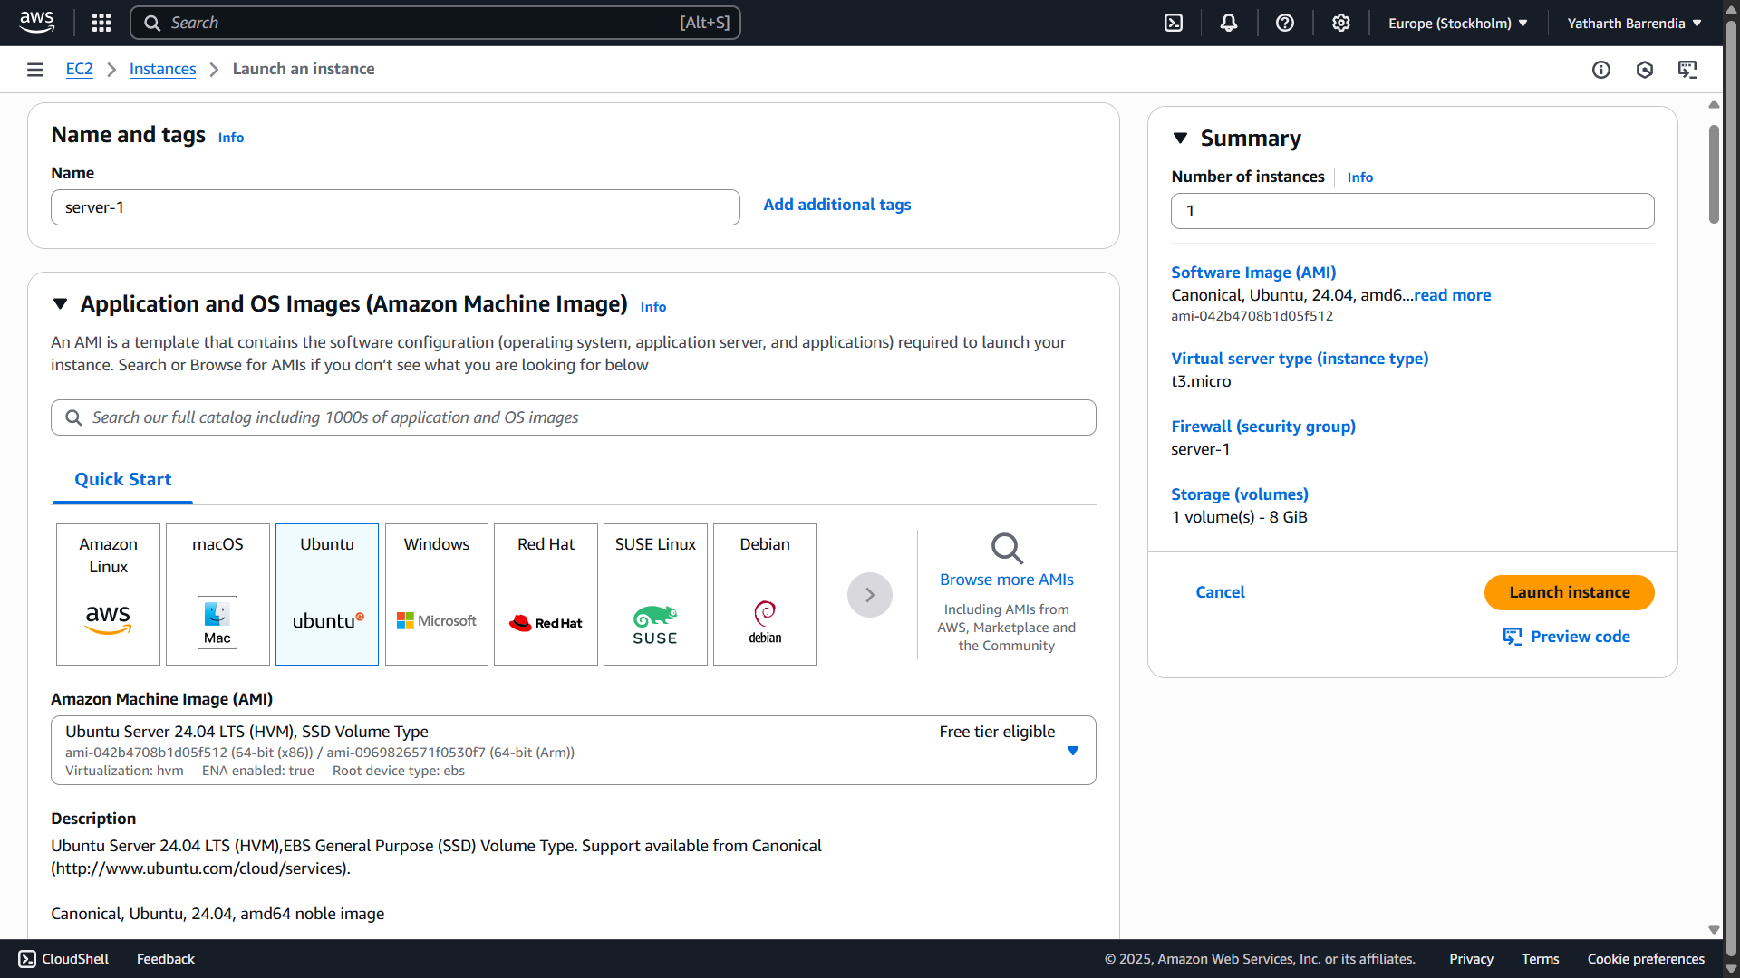

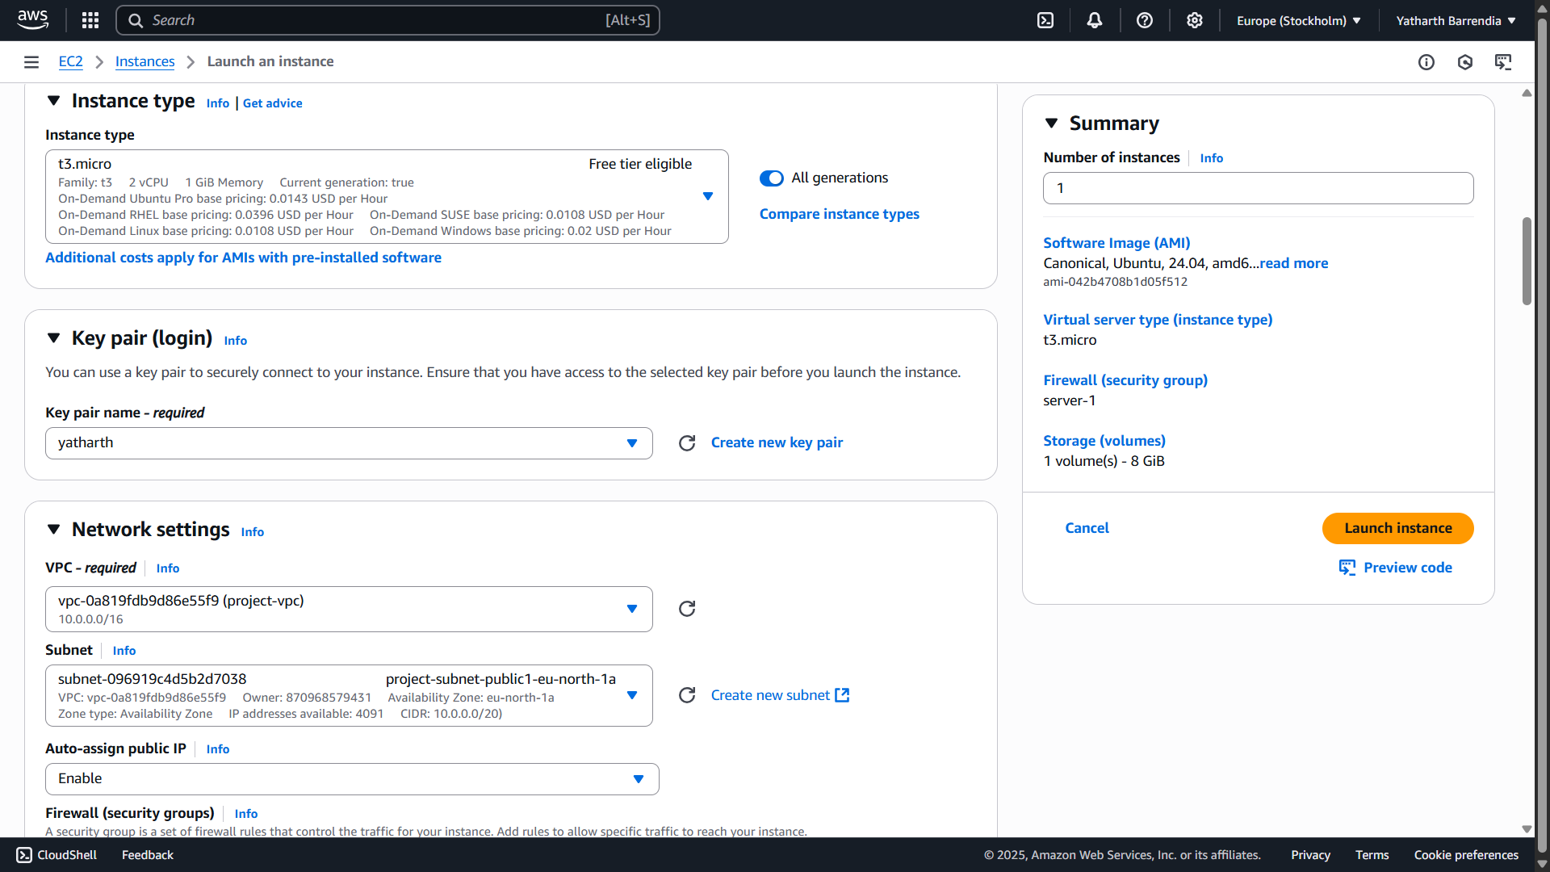

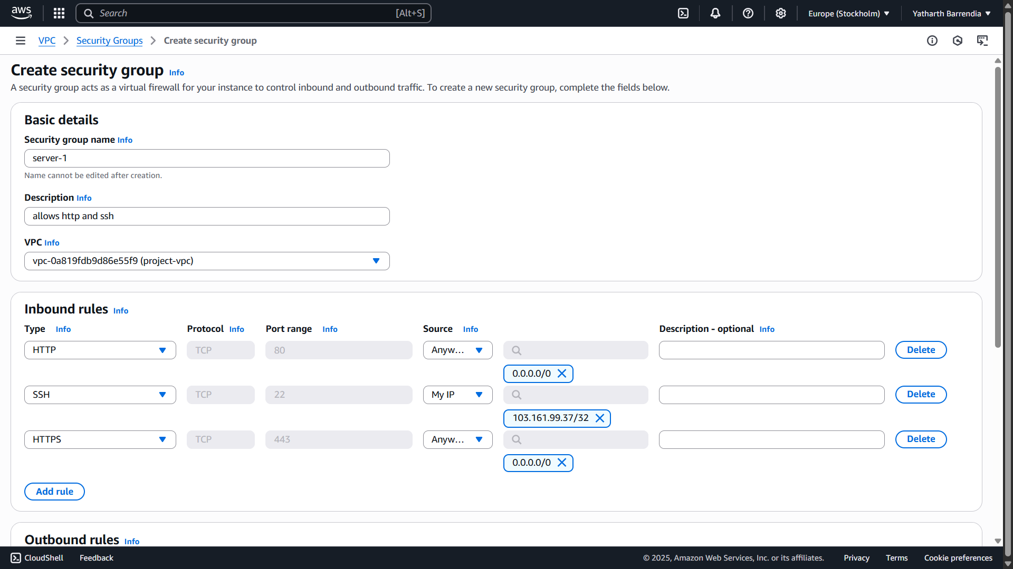

## USER DATA:

#!/bin/bash

apt-get update

apt-get install nginx -y

cat <<EOF > /var/www/html/index.html

<!DOCTYPE html>

<html lang="en">

<head>

<meta charset="UTF-8" />

<meta name="viewport" content="width=device-width, initial-scale=1.0"/>

<title>Welcome to $(hostname)</title>

<style>

body {

background: linear-gradient(135deg, #1e3c72, #2a5298);

color: white;

font-family: 'Segoe UI', Tahoma, Geneva, Verdana, sans-serif;

display: flex;

flex-direction: column;

justify-content: center;

align-items: center;

height: 100vh;

margin: 0;

}

h1 {

font-size: 3em;

margin: 0.2em 0;

}

p {

font-size: 1.2em;

color: #cce3ff;

}

.hostname {

background: #ffffff33;

padding: 0.5em 1em;

border-radius: 10px;

font-weight: bold;

}

</style>

</head>

<body>

<h1> Welcome to Yatharth Server!</h1>

<p>This server is proudly hosted as:</p>

<div class="hostname">$(hostname)</div>

</body>

</html>

EOF

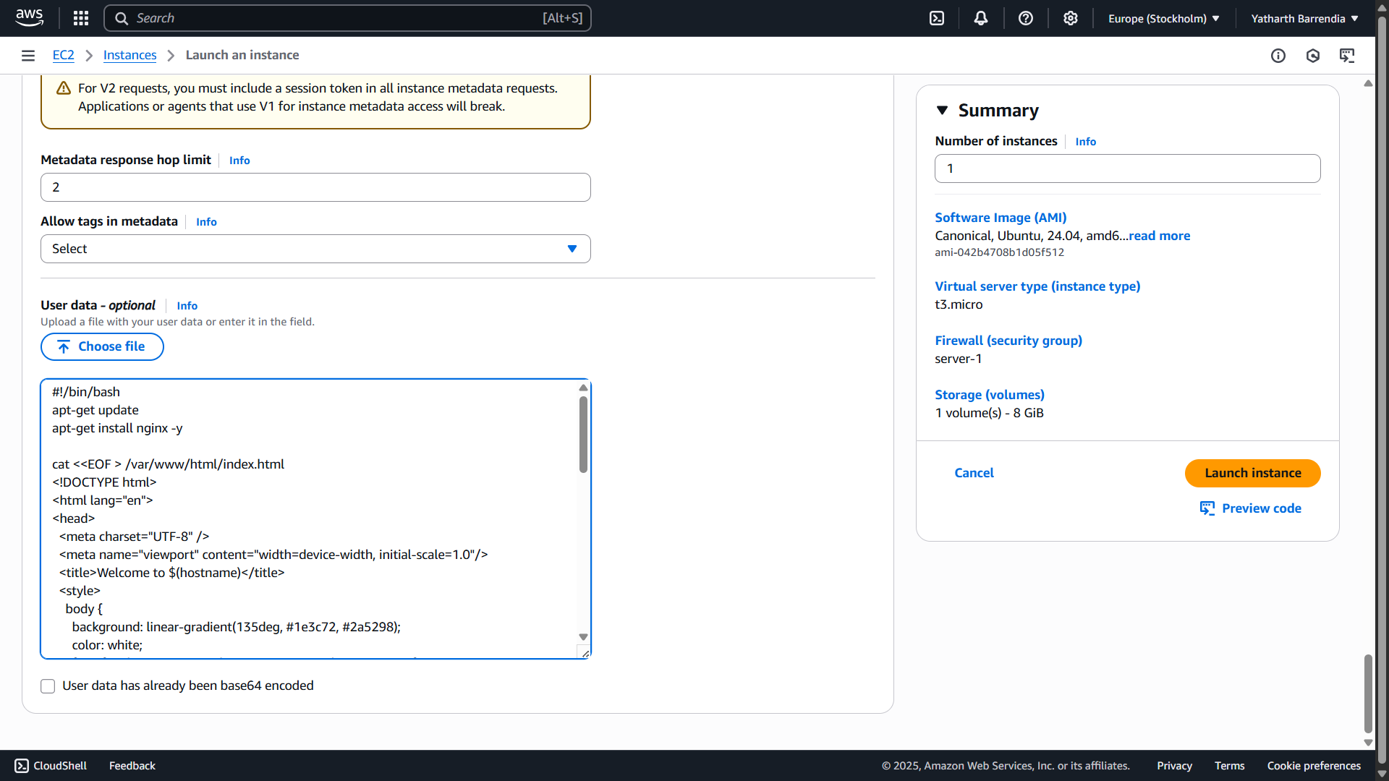

Similarly create three servers: server-1, server-2 and server-3 respectively

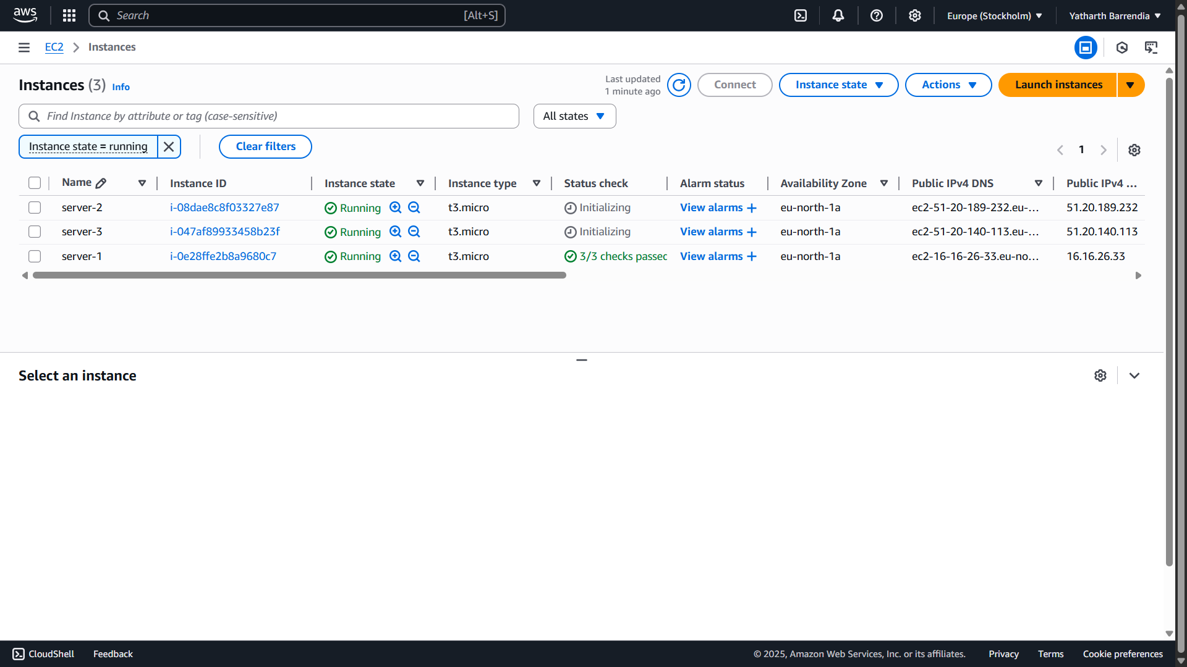

## Step 2: Create a Target Group and Register EC2 Instances

* Target Group Name: `Project-TargetGroup`
* Target Type: Instances
* Port: 80
* Register EC2 instances: `server-1`, `server-2`, `server-3`

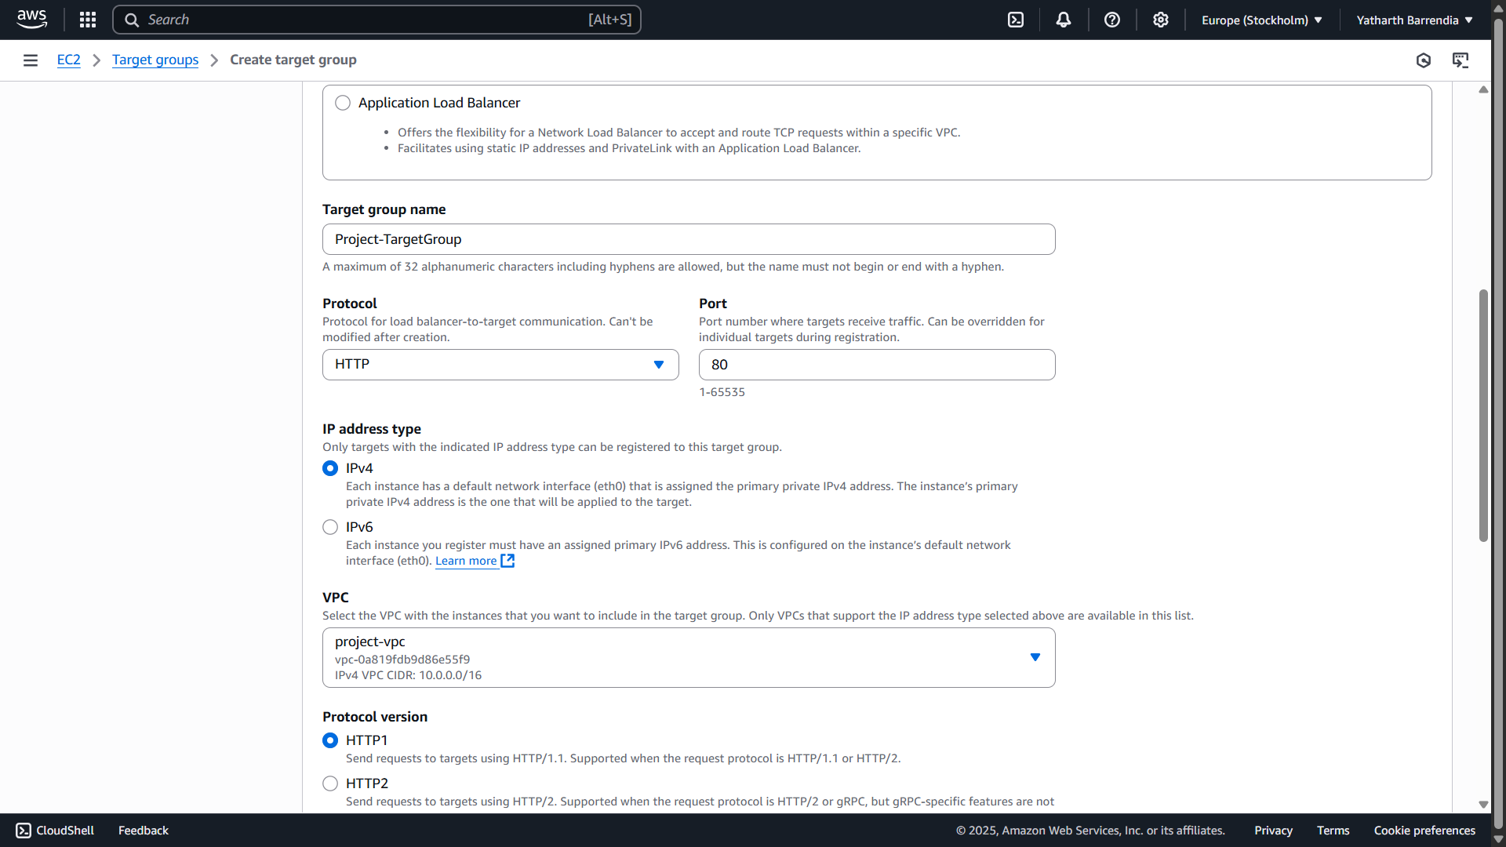

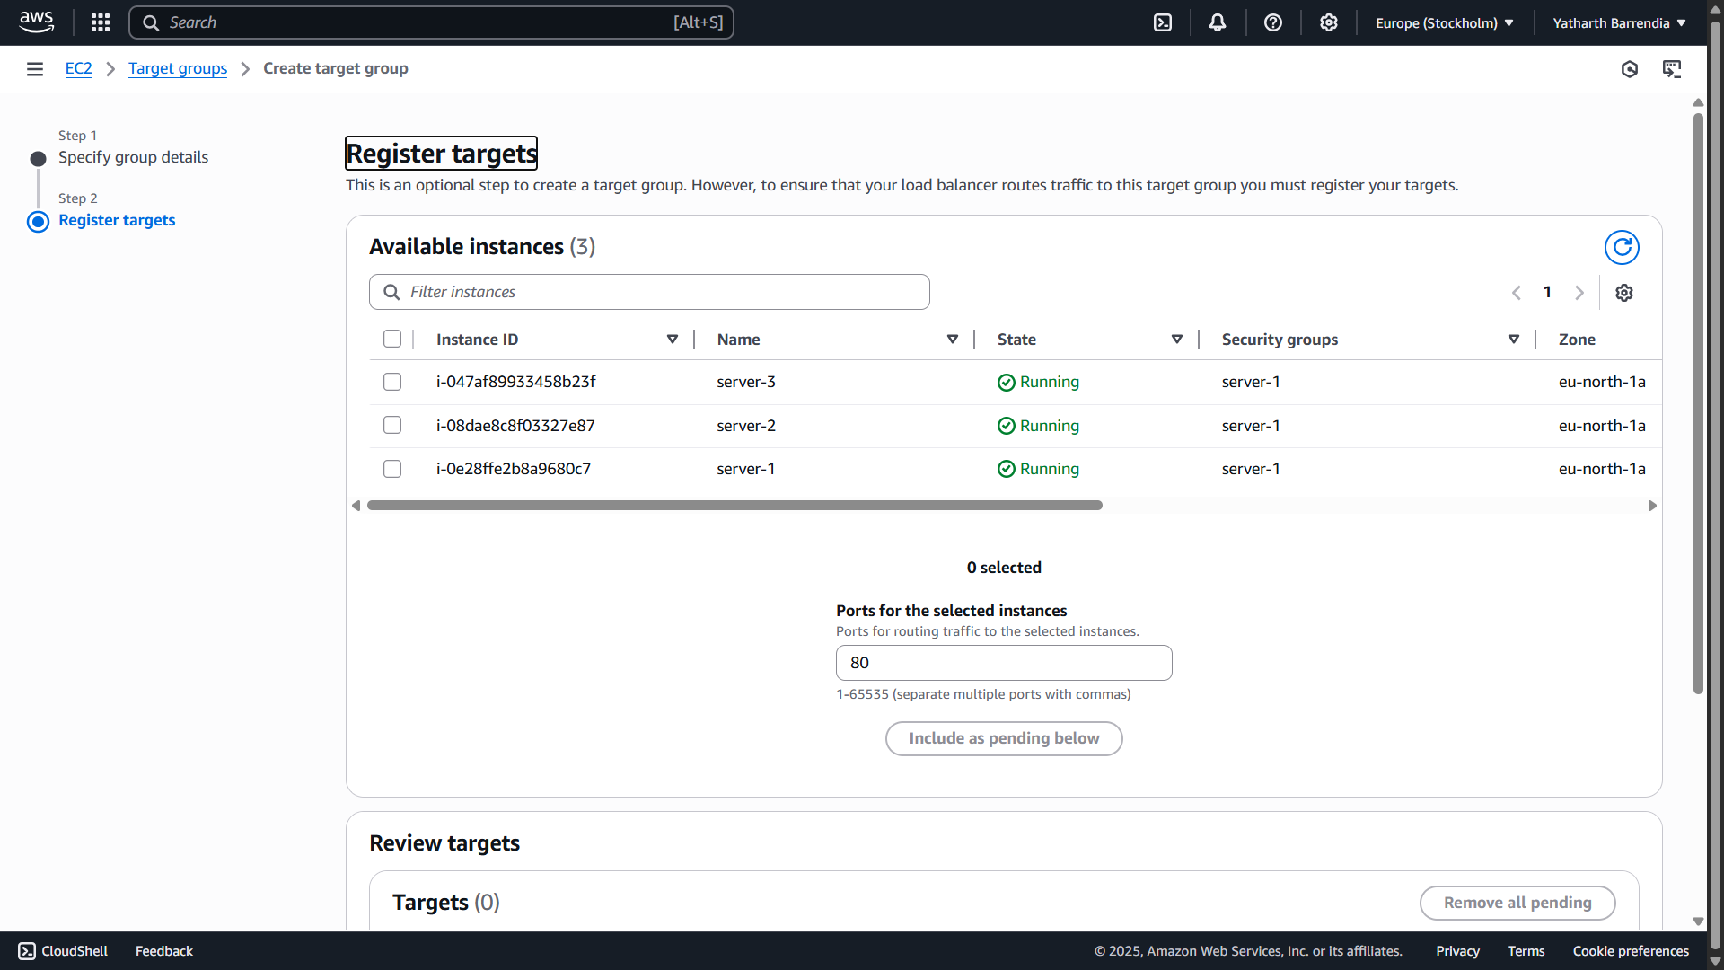

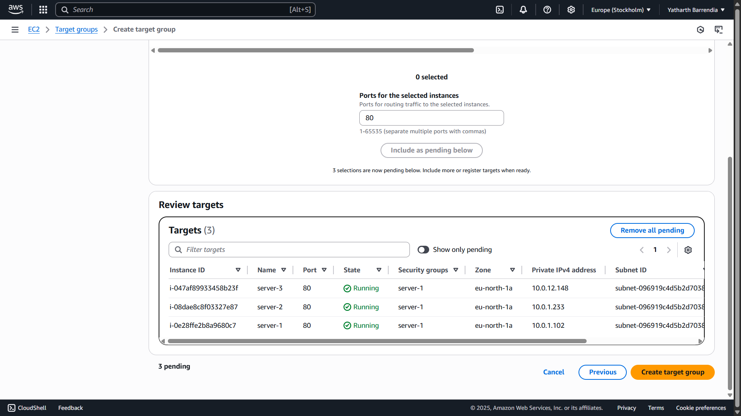

Verify Registration

* After creation:
* Go back to **Target Groups**
* Select your newly created target group
* Click on the **Targets** tab
* You should see the EC2 instances with a **healthy** status after a few seconds (if health checks pass)

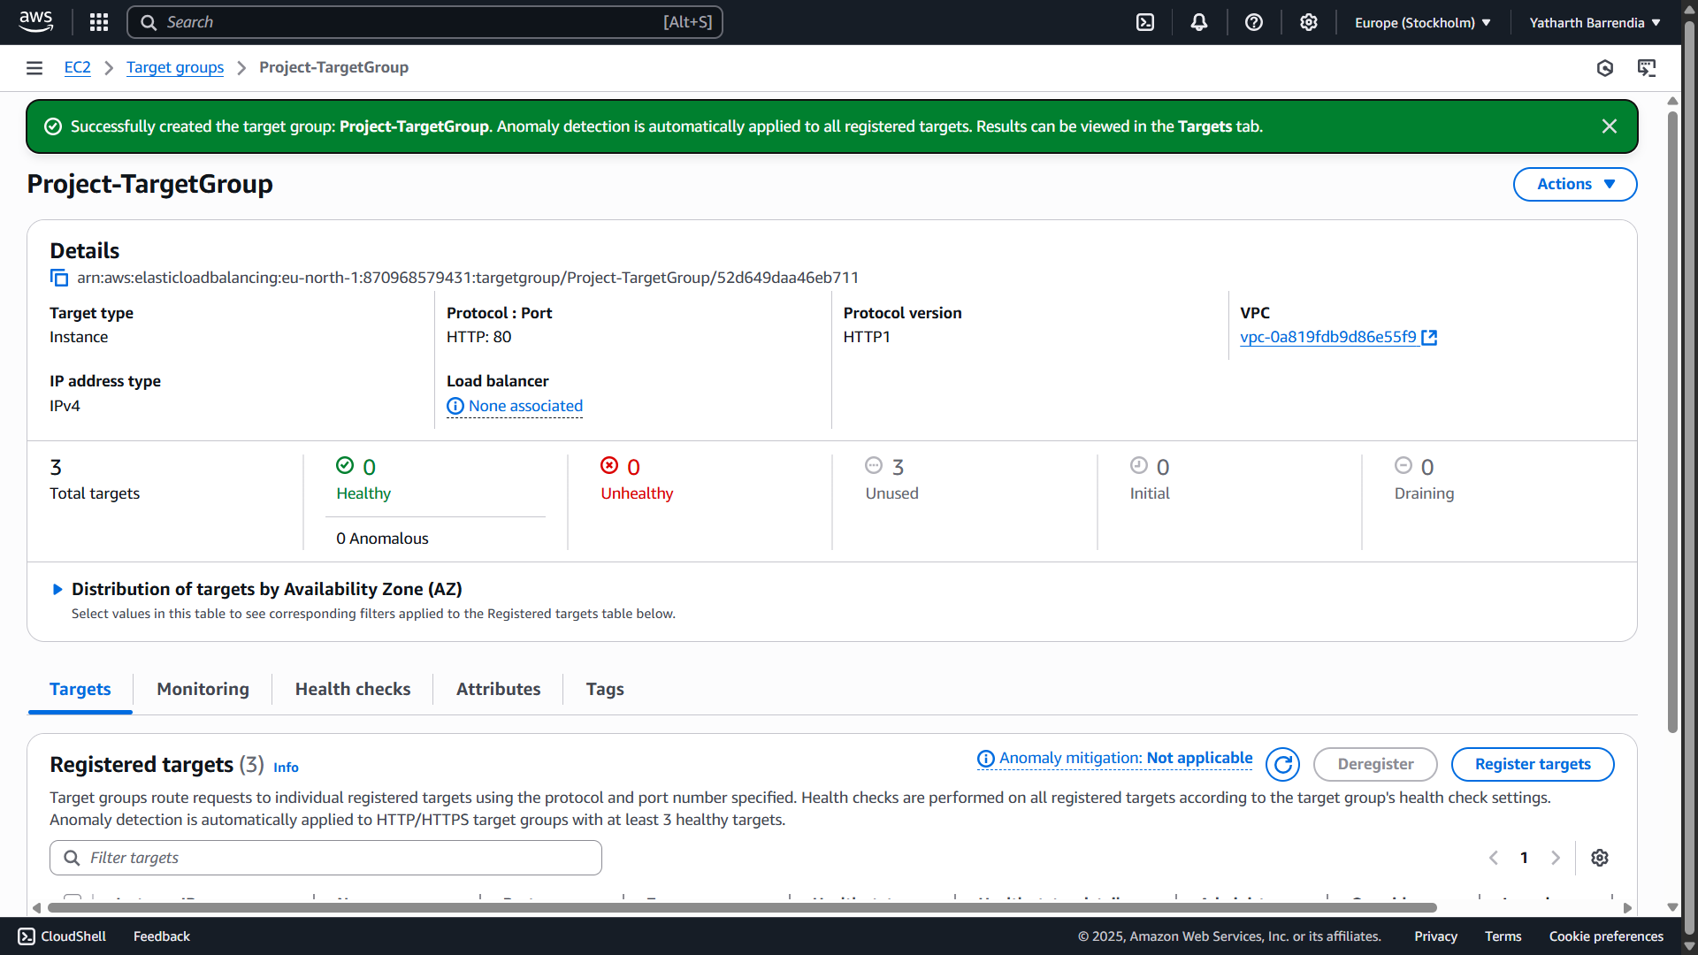

## Step 3: Create Application Load Balancer

* Name: Project-LoadBalancer
* Type: Application Load Balancer (ALB)
* Security Group: `ALB-Security`
* Listener: HTTP on port 80
* Associated Target Group: `Project-TargetGroup`

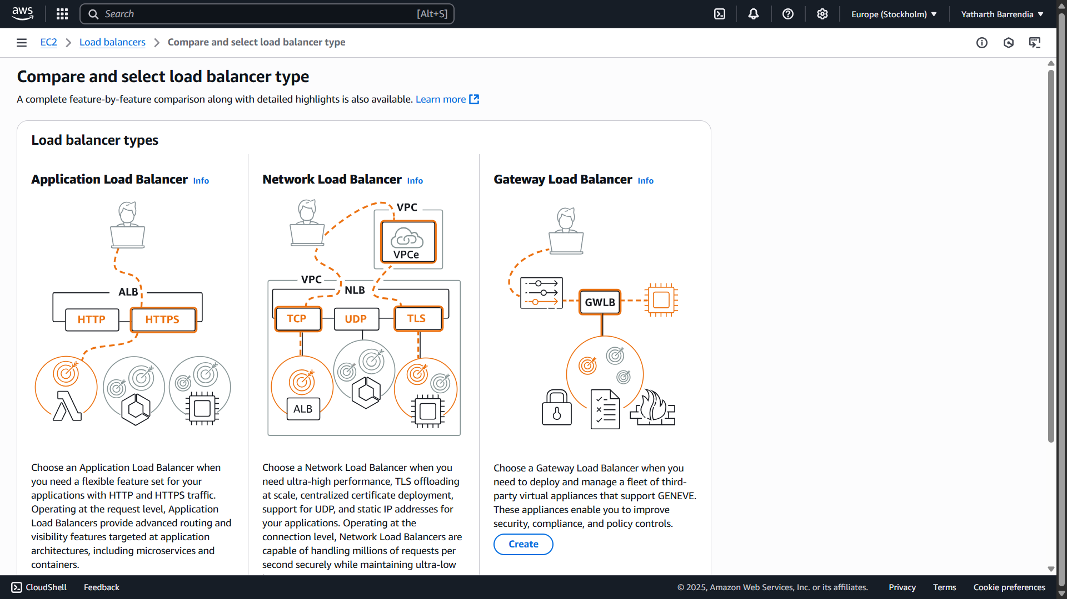

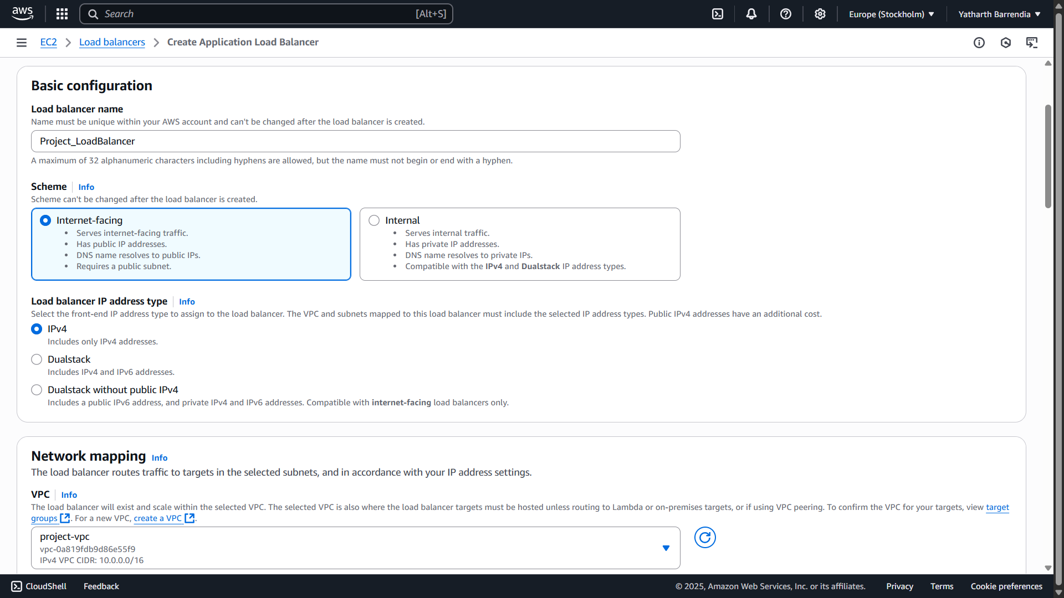

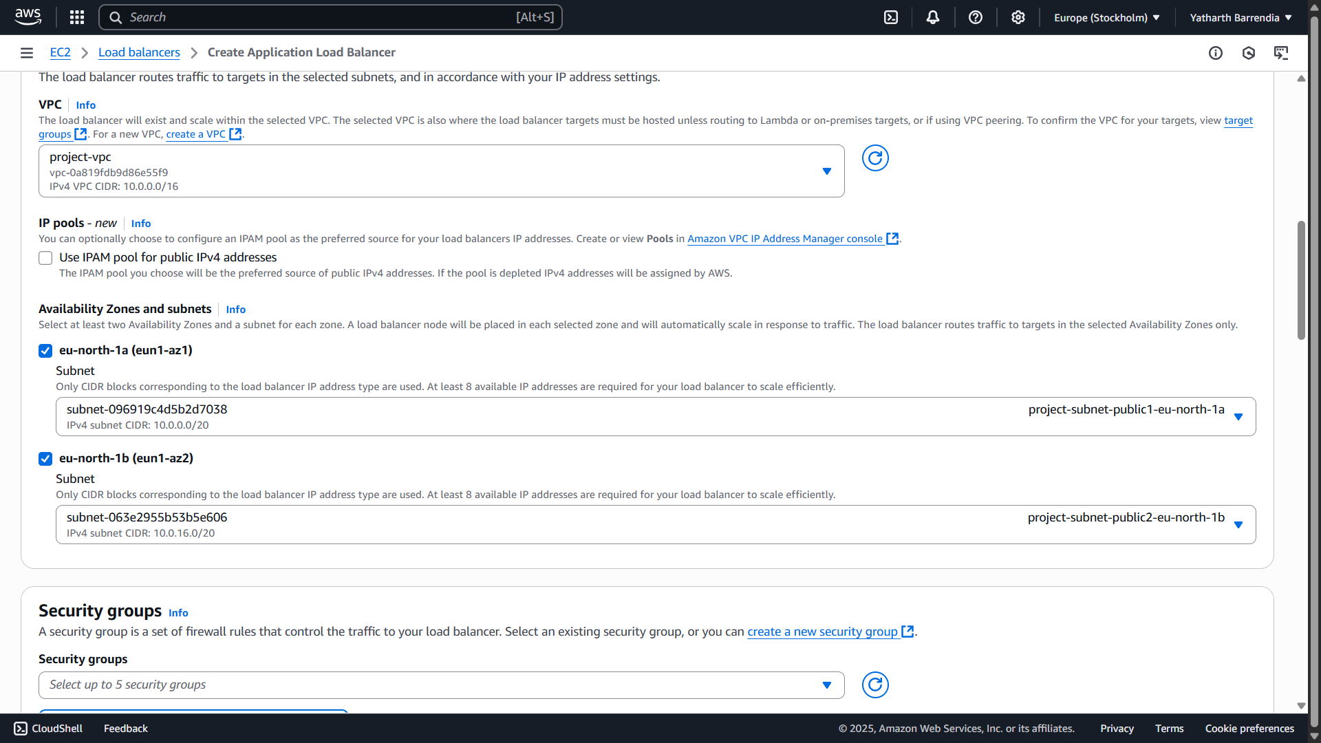

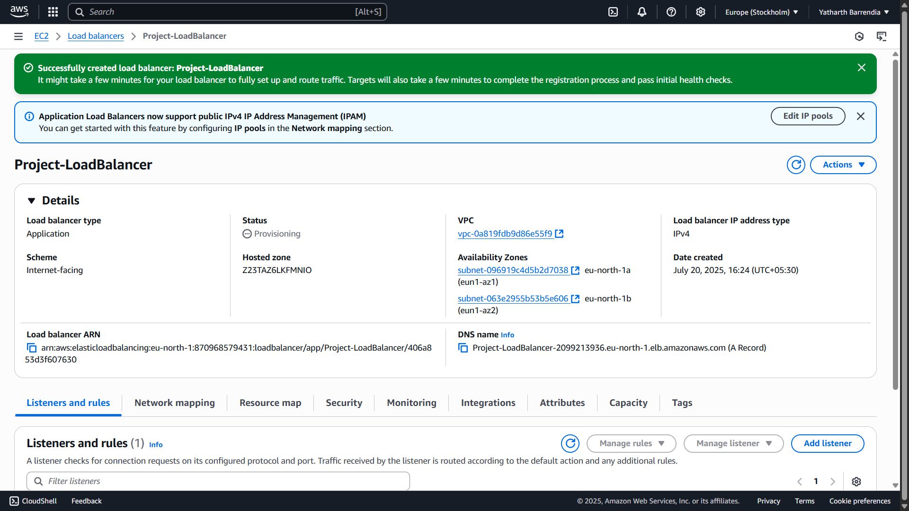

## Step 4: Configure Security Groups

* ALB-Security SG: Allow HTTP from `0.0.0.0/0`
* server-1 SG: Allow HTTP from `ALB-Security`

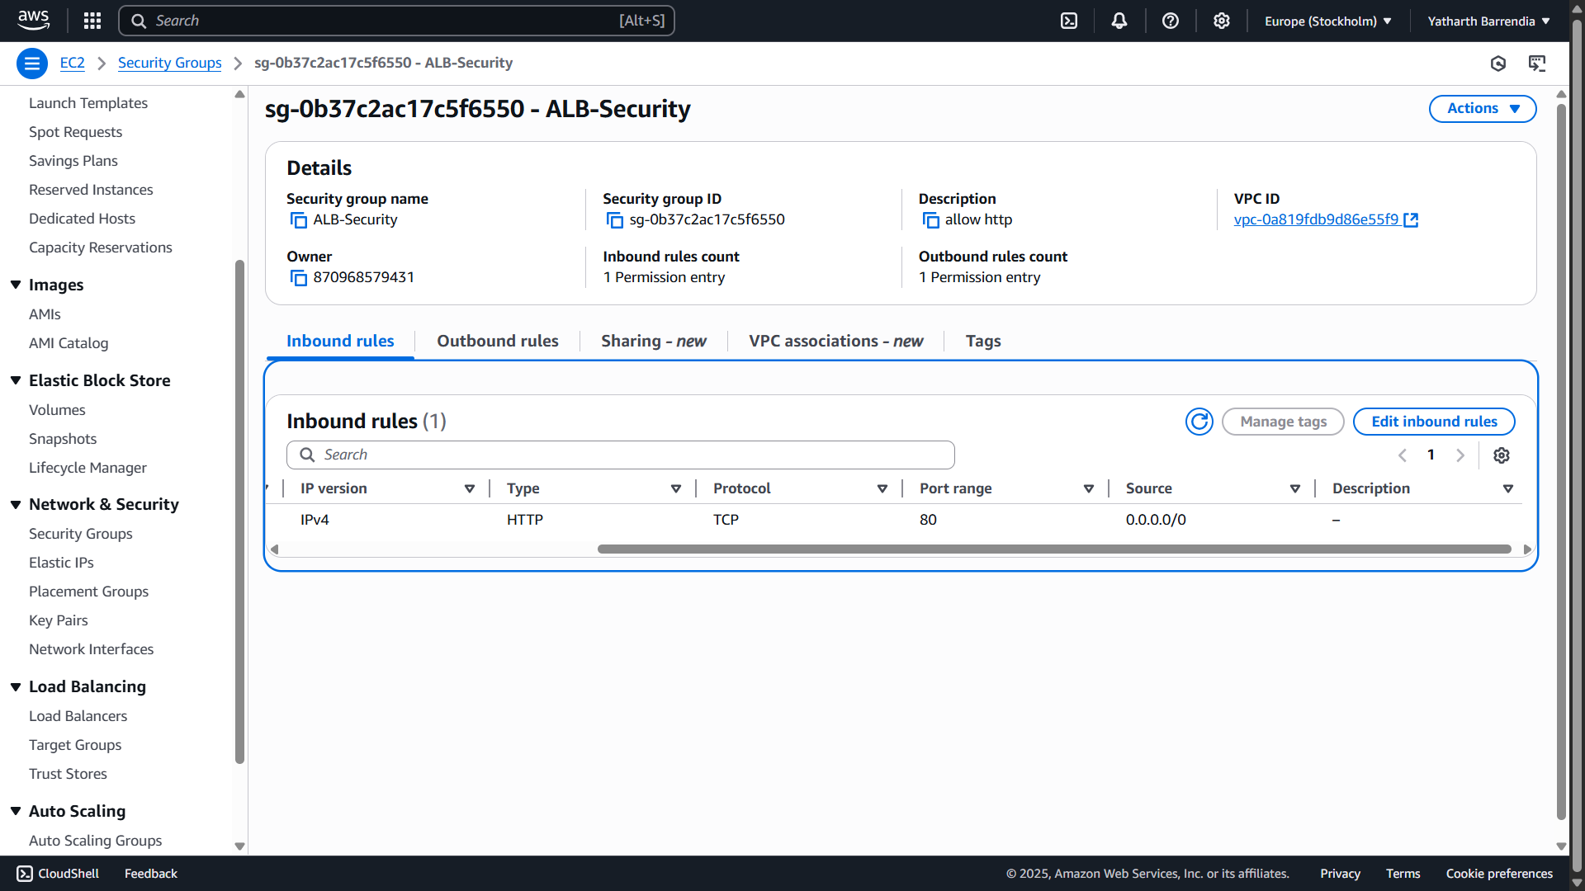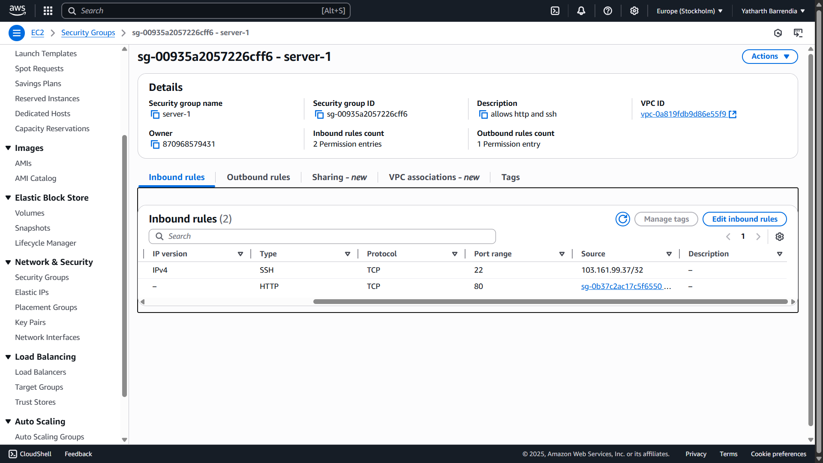

## Step 5: Final Verification

* Copy the DNS name of ALB: `Project-LoadBalancer`
* Paste in browser: Should show “Welcome to Yatharth Server!” page

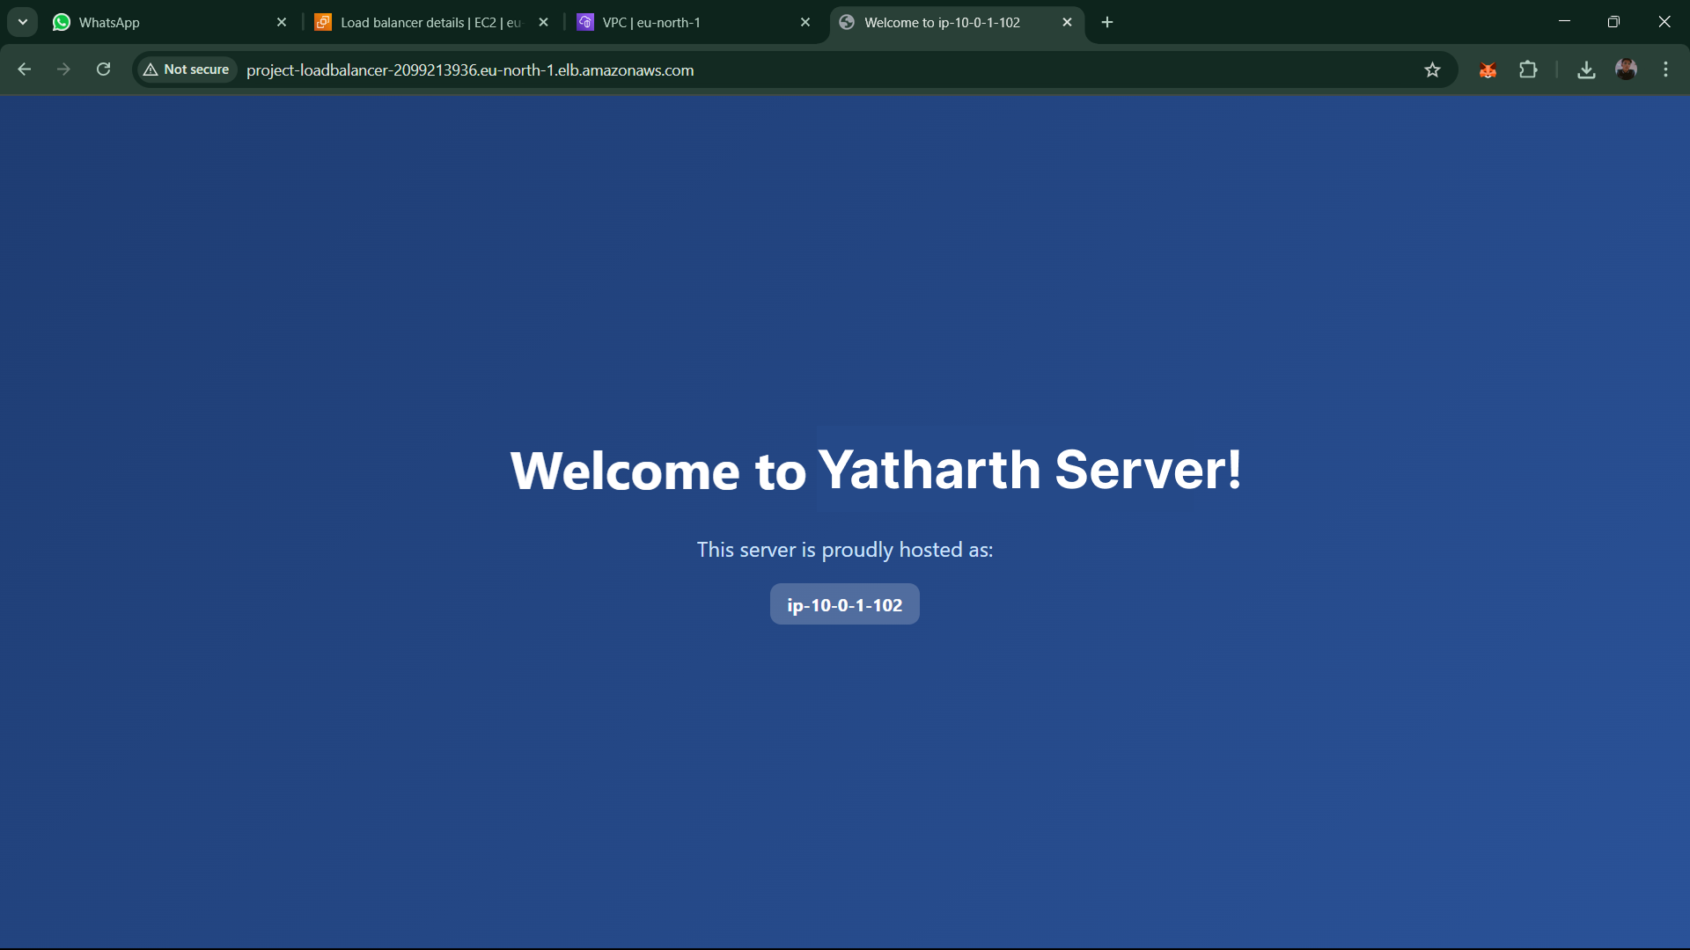

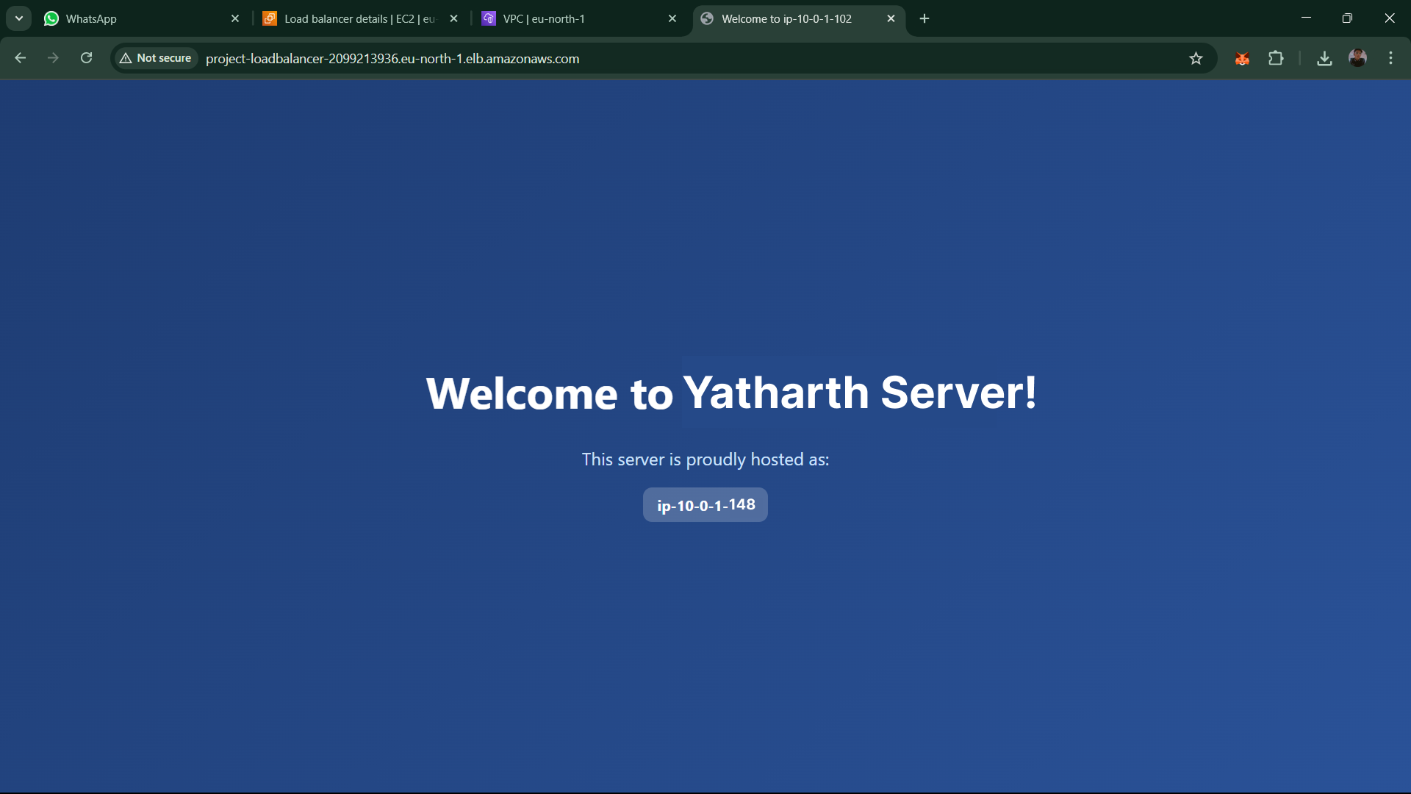

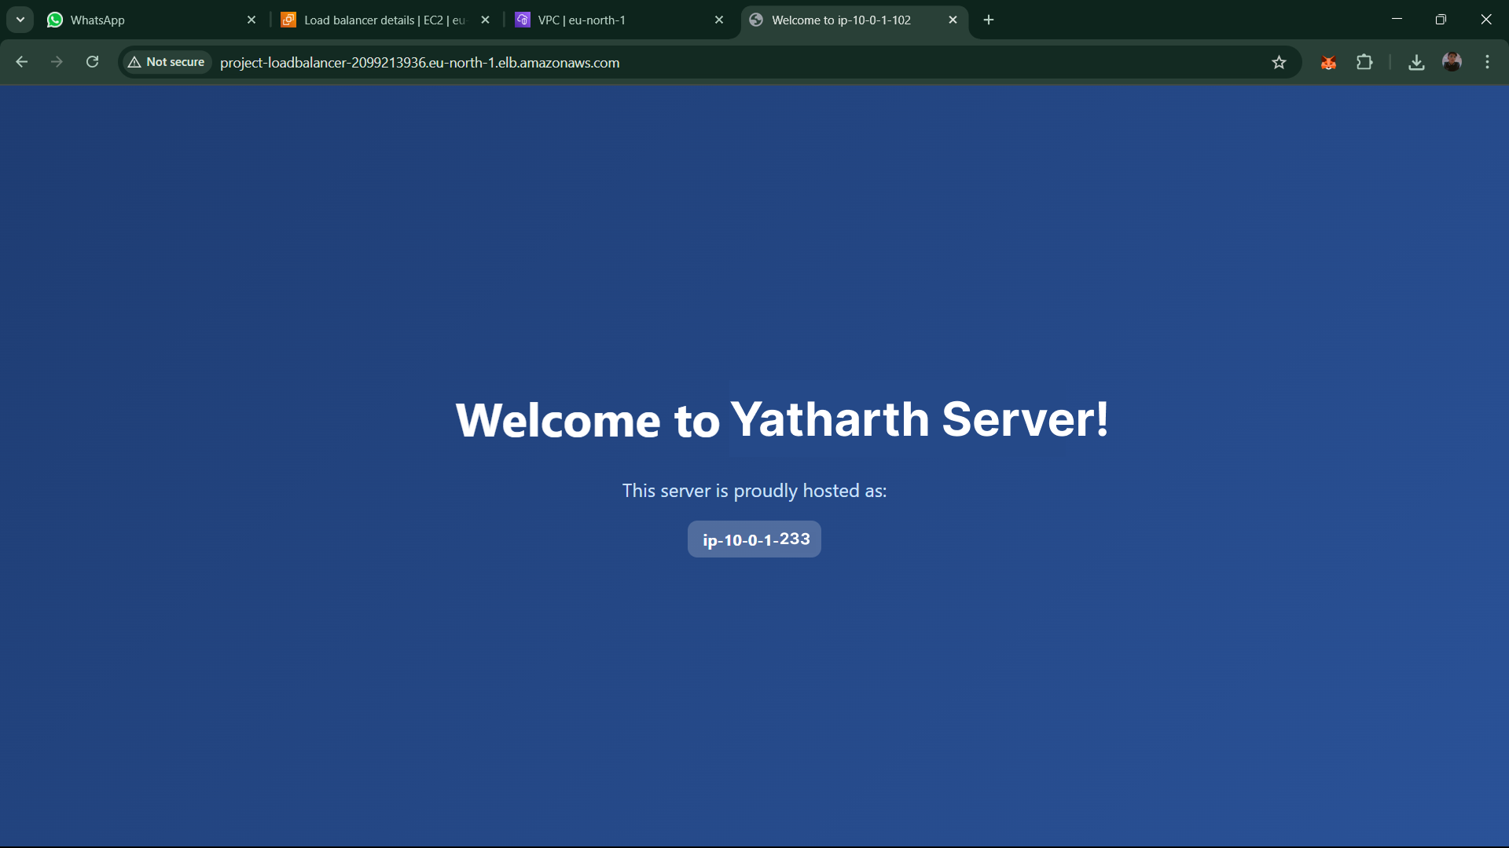

Hurray!! We are getting response from all three servers.